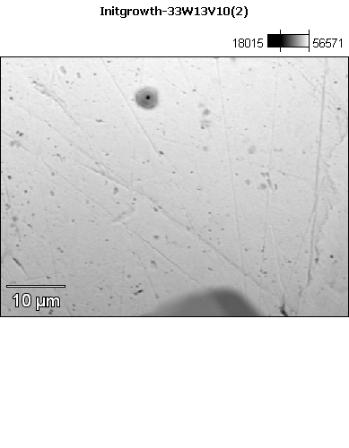

Data Type: Counts

Image Resolution: 512 by 384

Image Pixel Size: 0.12 µm

Map Resolution: 256 by 192

Map Pixel Size: 0.24 µm

Acc. Voltage: 13.0 kV

Magnification: 2100

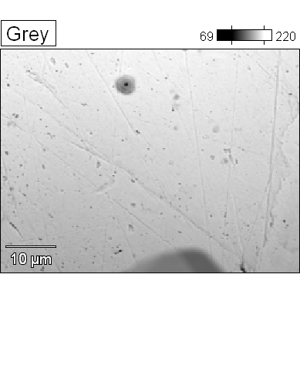 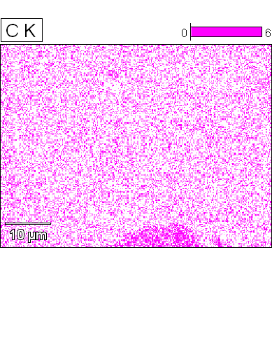



Data Type: Counts

Image Resolution: 512 by 384

Image Pixel Size: 0.12 µm

Map Resolution: 256 by 192

Map Pixel Size: 0.24 µm

Acc. Voltage: 13.0 kV

Magnification: 2100

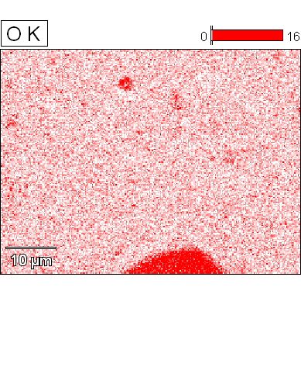 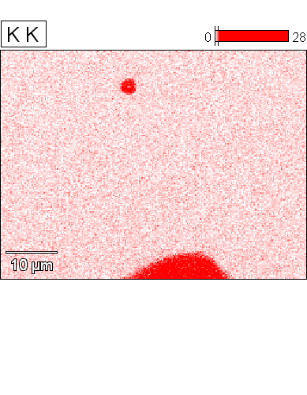



Data Type: Counts

Image Resolution: 512 by 384

Image Pixel Size: 0.12 µm

Map Resolution: 256 by 192

Map Pixel Size: 0.24 µm

Acc. Voltage: 13.0 kV

Magnification: 2100

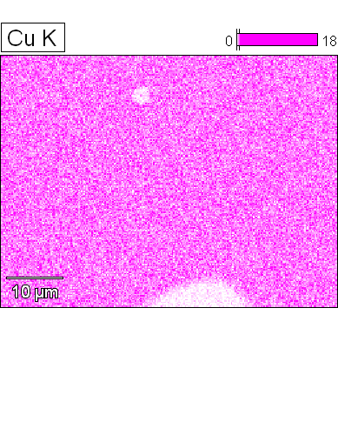 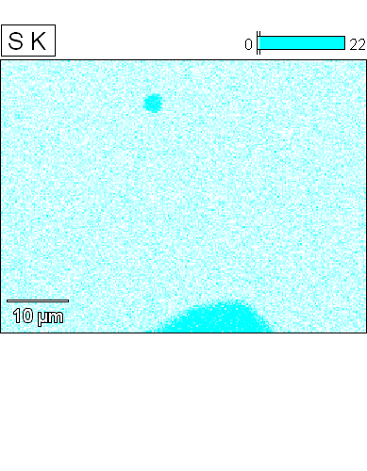



Data Type: Counts

Image Resolution: 512 by 384

Image Pixel Size: 0.12 µm

Map Resolution: 256 by 192

Map Pixel Size: 0.24 µm

Acc. Voltage: 13.0 kV

Magnification: 2100

